Athlete: _____________________________________ EMS Fire Law Enforcement Rescue

|  |  |  |  |
| --- | --- | --- | --- |
| Movement | 1st Round Time | 2nd Round Time | Final Time |
| 100m Suitcase Carry 35lbs. Kettlebell |  |  |  |
| 10 Double Kettlebell Deadlifts 35 lbs. |  |  |  |
| 30 Box Step Ups 20” Box |  |  |  |
| 5 Burpees |  |  |  |
| 5 Cycles of CPR (30 Compressions:2 Ventilations) |  |  |  |
| 5 Infant Back Slaps / 5 Infant Chest Thrust |  |  |  |
| Rounds + Reps Completed |  |  |  |

The competition will begin with the athlete standing at the start cone of the 100m suitcase carry. The athlete should be holding the 35 lbs. kettlebell just prior to the start. When the timer starts the athlete will complete the 100m suitcase carry by carrying the kettlebell around the building back to the start cone. After the athlete passes the start cone, the athlete will set the kettlebell down in front of the assigned 20” box where a second 35lbs. kettlebell will be waiting. At this time the athlete will complete 10 double kettlebell deadlifts using 35lbs. kettlebells. After the deadlifts are completed, the athlete will then complete 30 alternating box step ups using the assigned 20” box. After completing the box step-ups, the athlete will move to the area behind the boxes. The athlete will use this area to complete 5 Burpees. Once the burpees have been completed the athlete will move to the assigned adult CPR manikin where a CPR instructor will monitor the athlete while they complete 5 cycles of adult CPR (30 compressions: 2 breaths). When the athlete finishes 5 cycles of adult CPR, the athlete will use the assigned seat and infant CPR manikin to provide 5 back slaps and 5 chests thrust. Once the CPR station has been completed the athlete will move to the deadlift area where they will pick up one kettlebell and begin the next round. The athlete must go back to the start cone to begin the next suitcase carry. Time will be counted when the infant CPR manikin is placed on the competition floor. Tie break times will be the times after round 2 and round 1 if needed. There will be a 15-minute time cap on the workout. The score will be the fastest time, or the most number of rounds and reps completed before the 15-minute time is called.

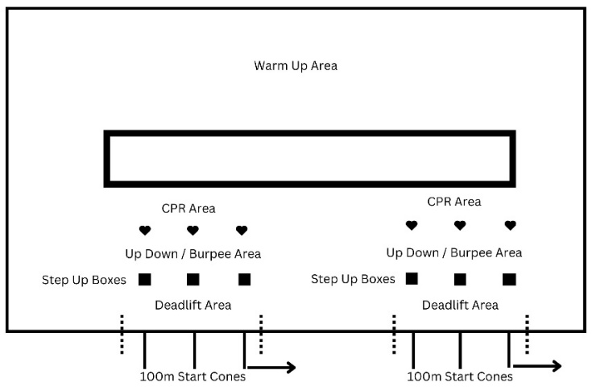

Judge: ________________________________________ Official Time: _______: ______

Round + Reps ______+ ______

**Description of Movements**

**Suitcase Carry**

The suitcase carry will be completed carrying a 35 lbs. kettlebell. The length of the carry will be 100m and the kettlebell can be carried in either hand. The athlete may switch hands during the carry but may not set the kettlebell down. If the athlete sets the kettlebell down for any reason before crossing the 100m line, the judge will consider this a “no rep” and the athlete will need to start the movement over.

**Double Kettlebell Deadlift**

To perform the double kettlebell deadlift the athlete should position a 35 lbs. kettlebell on either side of the feet and assume a hip width stance. The athlete should push the hips back and hinge forward while reaching down and grasp each handle of the kettlebells. The athlete should stand by driving through the whole foot and focus on pushing the floor away by extending the knees and hips. Once the hips are locked, reverse the movement by pushing the hips back and hinging forward. Return the kettlebells to the floor, reset, and repeat for the desired number of repetitions. The movement will be counted when the kettlebell touches the floor. If the athlete fails to touch the kettlebell to the floor, the judge will consider this a “no rep” and the athlete will need to start the movement over.

**Box Steps Ups**

The box steps-ups will be completed using a 20” box. For every repetition of the box step-up, the athlete starts with both feet on the ground and faces the box. The athlete must then step to the top of the box. Only the athlete’s feet may make contact with the box. The athletes' hands may not push into the legs during the step-up. The rep is credited when both of the athlete’s feet are on the top of the box and the hips and knees are fully extended. Athletes must alternate legs to start each step. If the athlete’s hands push into the legs or both feet do not contact the top of the box, the judge will consider the movement a “no rep” and the athlete will need to repeat that movement.

**Burpees**

To perform burpees the athlete will start standing with the feet about shoulder-width apart. The athlete will bend at the hips and the knees to bring the palms to the floor kicking the feet out behind them to land in the plank position. The athlete will lower the body to the ground and push back up jumping the feet forward so that they land right outside of your hands. Stand up straight to finish the burpee. If the chest fails to contact the ground the judge will consider the movement a “no-rep” and the athlete will need to repeat the movement.

**CPR**

The athlete will arrive at the CPR station to find an adult CPR manikin and an adult CPR mask with a one-way valve. The athlete will need to assemble the mask and valve and then complete 5 cycles of 30:2 CPR (30 compressions: 2 ventilations). This should take approximately two minutes. The athletes will be judged on proper depth of compression (approximately 2”) and rate (100-120 compressions per minute). This station will be judged by a certified AHA CPR instructor. Athletes will be given (two) warnings of improper depth of compression or improper rate and then the movement will be considered a “no-rep” and the athlete will need to repeat the movement.

**Infant Choking**

The athlete will find a chair with an infant CPR manikin laying on it. The athlete will pick up the infant and sit on the chair. The athlete will support the infant’s head and perform five back slaps. While supporting the head the athlete will roll the infant over and perform five chest thrust. This station will be judged by a certified AHA CPR instructor. Athletes will be given (one) warning of not supporting the infants head and then the movement will be considered a “no-rep” and the athlete will need to repeat the movement.