First Responder: _________________________________ EMS Fire Law Enforcement Rescue

|  |  |  |  |
| --- | --- | --- | --- |
| Movement | 1st Round Time | 2nd Round Time | Final Time |
| 100m Suitcase Carry 35 lbs. Kettlebell |  |  |  |
| 5 Double Kettlebell Deadlifts 35 lbs. |  |  |  |
| 30 Box Step Ups 12” Box |  |  |  |
| 5 Up Downs |  |  |  |
| 5 Cycles of CPR (30 Compressions:2 Ventilations) |  |  |  |
| 5 Infant Back Slaps / 5 Infant Chest Thrust |  |  |  |
| Rounds + Reps Completed |  |  |  |

The competition will begin with the first responder standing at the start cone of the 100m suitcase carry. The first responder should be holding the 35 lbs. kettlebell just prior to the start. When the timer starts the first responder will complete the 100m suitcase carry by carrying the kettlebell around the building back to the start cone. After the first responder passes the start cone, the first responder will set the kettlebell down in front of the assigned 12” box where a second 35lbs. kettlebell will be waiting. At this time the first responder will complete 5 double kettlebell deadlifts using 35lbs. kettlebells. After the deadlifts are completed the first responder will then complete 30 alternating box step ups using the assigned 12” box. After completing the box step-ups, the first responder will move to the area behind the boxes. The first responder will use this area to complete 5 up downs. Once the up downs have been completed the first responder will move to the assigned adult CPR manikin where a CPR instructor will monitor the first responder while they complete 5 cycles of adult CPR (30 compressions: 2 breaths). When the first responder finishes 5 cycles of adult CPR, the first responder will use the assigned seat and infant CPR manikin to provide 5 back slaps and 5 chests thrust. Once the CPR station has been completed the first responder will move to the deadlift area where they will pick up one kettlebell and begin the next round. The first responder must go back to the start cone to begin the next suitcase carry. Time will be counted when the infant CPR manikin is placed on the competition floor. Tie break times will be the times after round 2 and round 1 if needed. There will be a 15-minute time cap on the workout. The score will be the fastest time, or the most number of rounds and reps completed before the 15-minute time is called.

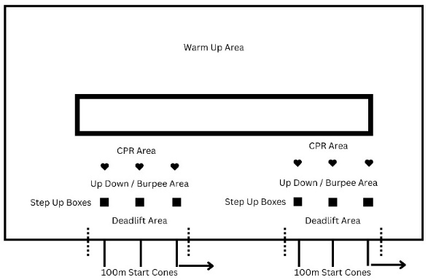

Judge: ________________________________________ Official Time: _______: ______

Round + Reps ______+ ______

**Description of Movements**

**Suitcase Carry**

The suitcase carry will be completed carrying a 35 lbs. kettlebell. The length of the carry will be 100m and the kettlebell can be carried in either hand. The first responder may switch hands during the carry but may not set the kettlebell down. If the first responder sets the kettlebell down for any reason before crossing the 100m line, the judge will consider this a “no rep” and the first responder will need to start the movement over.

**Double Kettlebell Deadlift**

To perform the double kettlebell deadlift the first responder should position a 35 lbs. kettlebell on either side of the feet and assume a hip width stance. The first responder should push the hips back and hinge forward while reaching down and grasp each handle of the kettlebells. The first responder should stand by driving through the whole foot and focus on pushing the floor away by extending the knees and hips. Once the hips are locked, reverse the movement by pushing the hips back and hinging forward. Return the kettlebells to the floor, reset, and repeat for the desired number of repetitions. The movement will be counted when the kettlebell touches the floor. If the first responder fails to touch the kettlebell to the floor, the judge will consider this a “no rep” and the first responder will need to start the movement over.

**Box Steps Ups**

The box steps-ups will be completed using a 12” box. For every repetition of the box step-up, the first responder starts with both feet on the ground and faces the box. The first responder must then step to the top of the box. Only the first responder’s feet may make contact with the box. The first responders' hands may not push into the legs during the step-up. The rep is credited when both of the first responder’s feet are on the top of the box and the hips and knees are fully extended. First responders must alternate legs to start each step. If the first responder’s hands push into the legs or both feet do not contact the top of the box, the judge will consider the movement a “no rep” and the first responder will need to repeat that movement.

**Up Downs**

To complete the up down the first responder will squat down and put their hands on the floor underneath their shoulders. From there the first responder should take the body weight into the hands and shoulders and jump both feet out backward to straighten the legs. From this position, jump the legs in underneath the body, landing with the feet at shoulder width. Transfer the bodyweight back into the legs and stand up as if doing the upward part of a squat.

**CPR**

The first responder will arrive at the CPR station to find an adult CPR manikin and an adult CPR mask with a one-way valve. The first responder will need to assemble the mask and valve and then complete 5 cycles of 30:2 CPR (30 compressions: 2 ventilations). This should take approximately two minutes. The first responders will be judged on proper depth of compression (approximately 2”) and rate (100-120 compressions per minute). This station will be judged by a certified AHA CPR instructor. First responders will be given (two) warnings of improper depth of compression or improper rate and then the movement will be considered a “no-rep” and the first responder will need to repeat the movement.

**Infant Choking**

The first responder will find a chair with an infant CPR manikin laying on it. The first responder will pick up the infant and sit on the chair. The first responder will support the infant’s head and perform five back slaps. While supporting the head the first responder will roll the infant over and perform five chest thrust. This station will be judged by a certified AHA CPR instructor. First responders will be given (one) warning of not supporting the infants head and then the movement will be considered a “no-rep” and the first responder will need to repeat the movement.